PHP meta-runners for TeamCity

The [Meta-runner Power Pack for TeamCity 8](https://github.com/JetBrains/meta-runner-power-pack) contains a set of PHP-related meta runners:

* Run arbitrary PHP code using the *PHP* runner
* Install a specific Composer dependency using the *Install Composer package* runner
* Install/update packages from composer.json using the *Run Composer* runner
* Run Phing build script using the *Phing* runner
* Run PHPUnit tests (with code coverage reporting) using the *PHPUnit* runner

Before being able to use these runners, the following prerequisites should be satisfied:

* Make sure that a PHP runtime is available on the build agents and that it is enlisted in the PATH variable.
* Install the meta runners into your project by following instructions at <https://github.com/jetbrains/meta-runner-power-pack>

Most runners will report back their output in the TeamCity build log. The following is the output of the *PHP* runner:

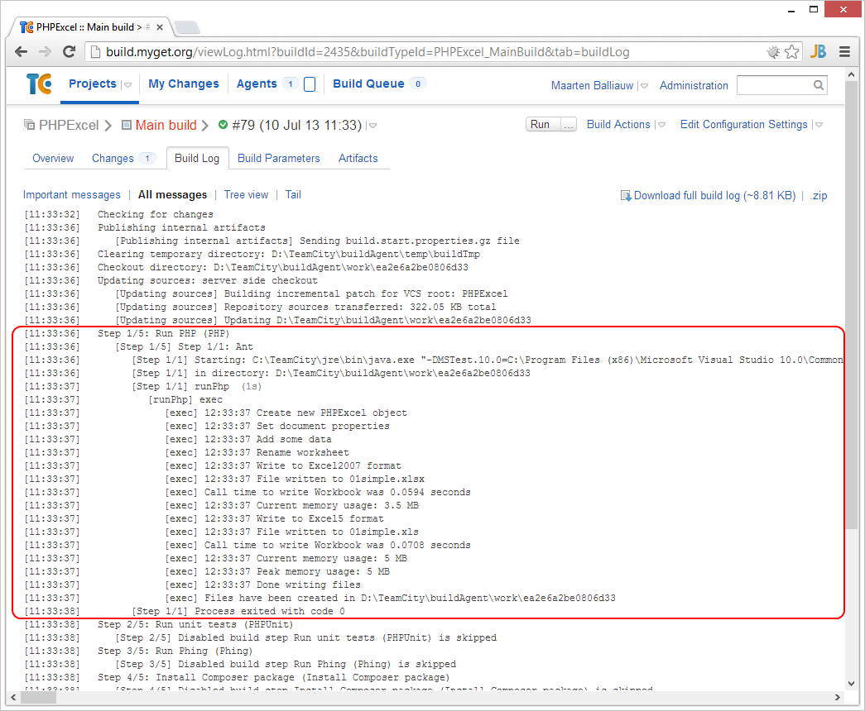

# PHP Runner

The *PHP* runner allows running arbitrary PHP code. The following options can be specified:

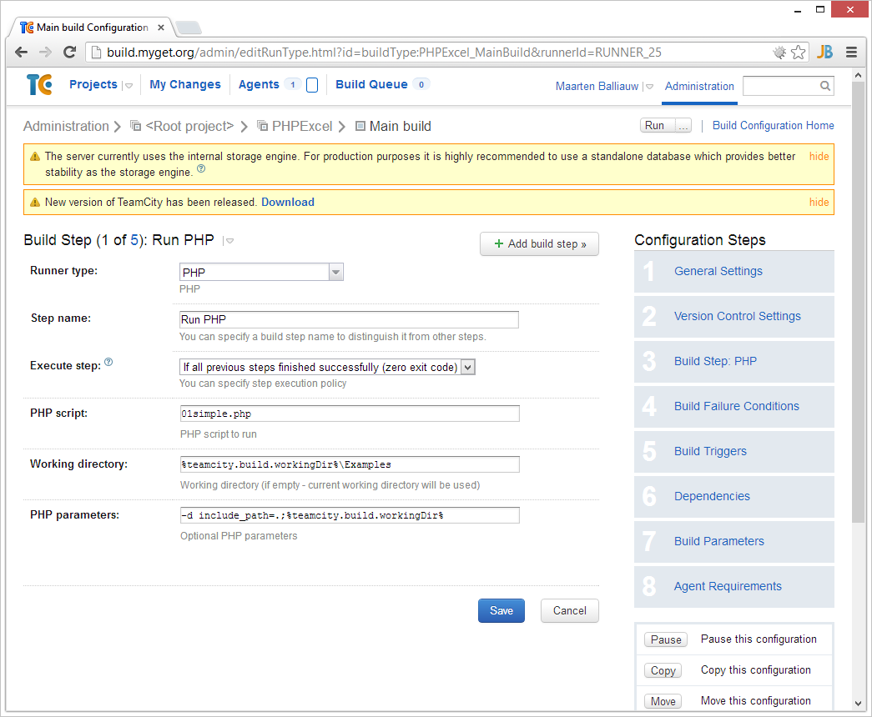

* **PHP script**: The PHP script to run.
* **Working directory:** The working directory to use. If omitted, the current working directory will be used.
* **PHP parameters**: Additional parameters for the PHP command line.

# Install Composer package runner

The *Install Composer package* runner allows installing a given Composer dependency during the build.

This build step will automatically download *composer.phar* from the [GetComposer.org](http://GetComposer.org) website during build.

The following options can be specified:

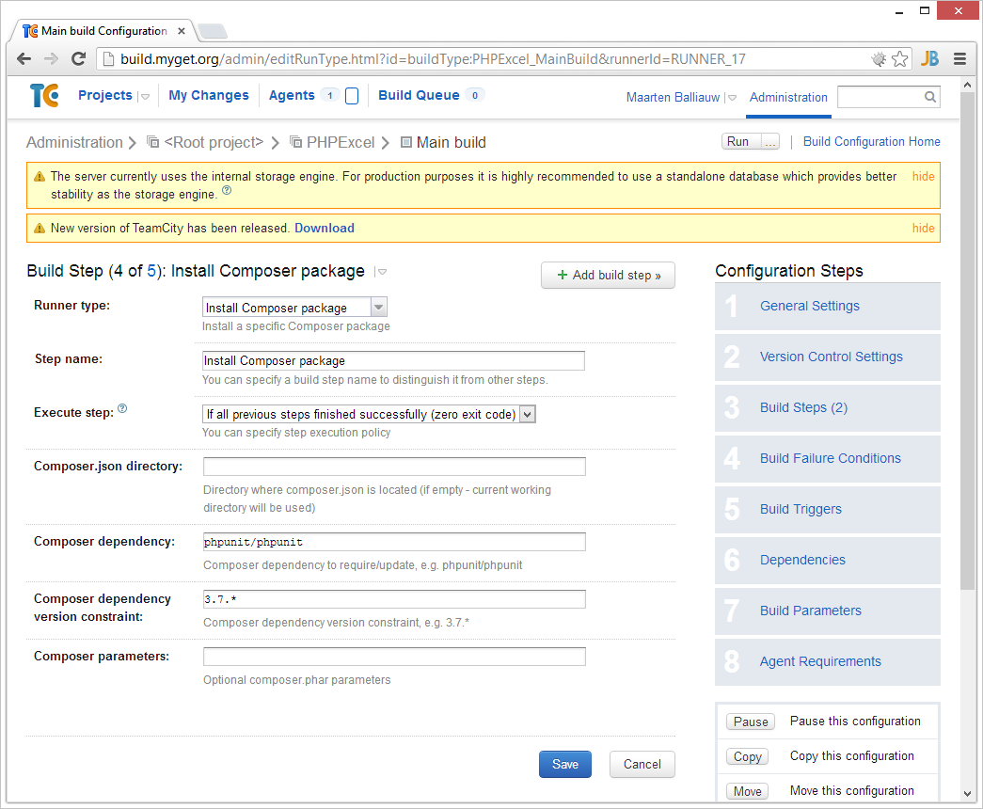

* **Composer.json directory**: The directory where composer.json is located. Note that a composer.json file ***must*** exist in this directory for the runner to work.
* **Composer dependency:** The Composer dependency to install, for example *phpunit/phpunit*.
* **Composer dependency version constraint**: A version constraint for the Composer dependency, for example *3.7.\**.
* **Composer parameters**: Additional parameters for the Composer command line.

# Run Composer runner

The *Run Composer* runner allows installing or updating Composer deoendencies during the build.

This build step will automatically download *composer.phar* from the [GetComposer.org](http://GetComposer.org) website during build.

The following options can be specified:

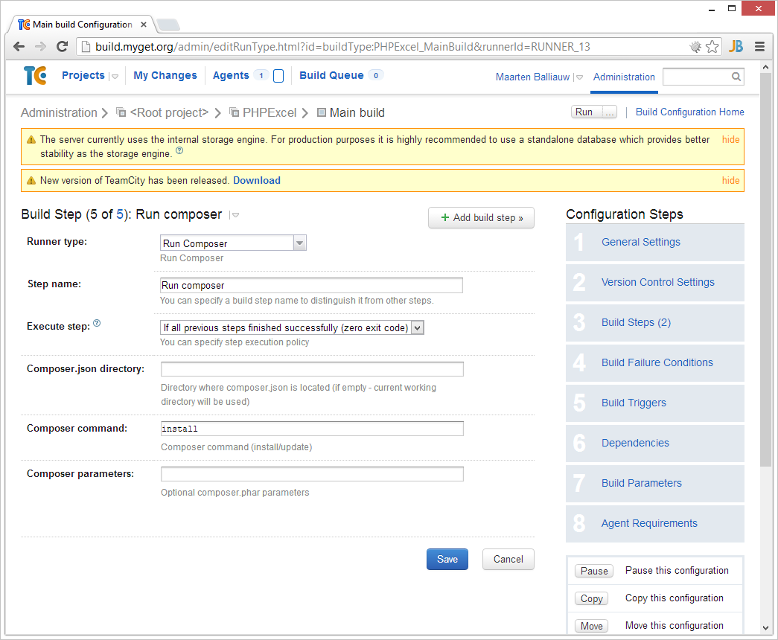

* **Composer.json directory**: The directory where composer.json is located. Note that a composer.json file ***must*** exist in this directory for the runner to work.
* **Composer command:** Either *install* or *update*, depending on the use case.
* **Composer parameters**: Additional parameters for the Composer command line.

# Phing runner

The *Phing* runner allows running a Phing script during the build.

This build step will use a Phing executable available on the build agent if specified, or automatically download the latest *phing-latest.phar* from the [Phing.info](http://www.phing.info) website during build.

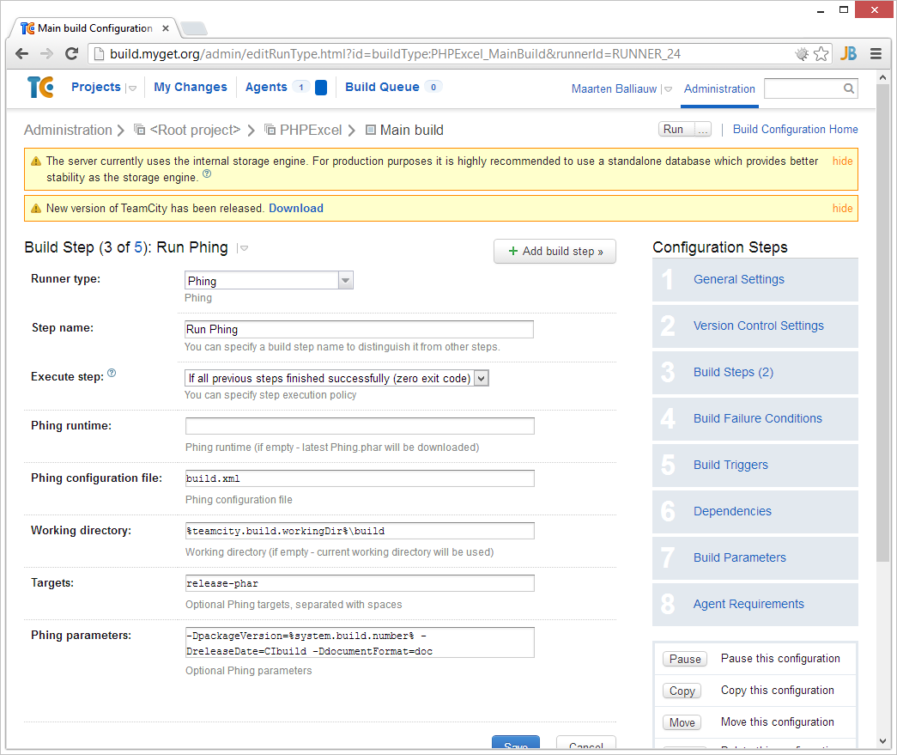

The following options can be specified:

* **Phing runtime**: The Phing executable to use during build. If omitted, the latest Phing version will be downloaded during build.
* **Phing configuration file:** The build.xml file to run.
* **Working directory:** The working directory to use. If omitted, the current working directory will be used.
* **Targets:** The build targets to be run, separated by spaces.
* **Phing parameters**: Additional parameters for the Phing command line.

# PHPUnit runner

The *PHPUnit* runner allows running PHPUnit tests during the build and will optionally publish code coverage results to TeamCity.

This build step will use a PHPUnit executable available on the build agent if specified, or automatically download the latest *phpunit.phar* from the [PHPUnit.de](http://www.phpunit.de) website during build.

The following options can be specified:

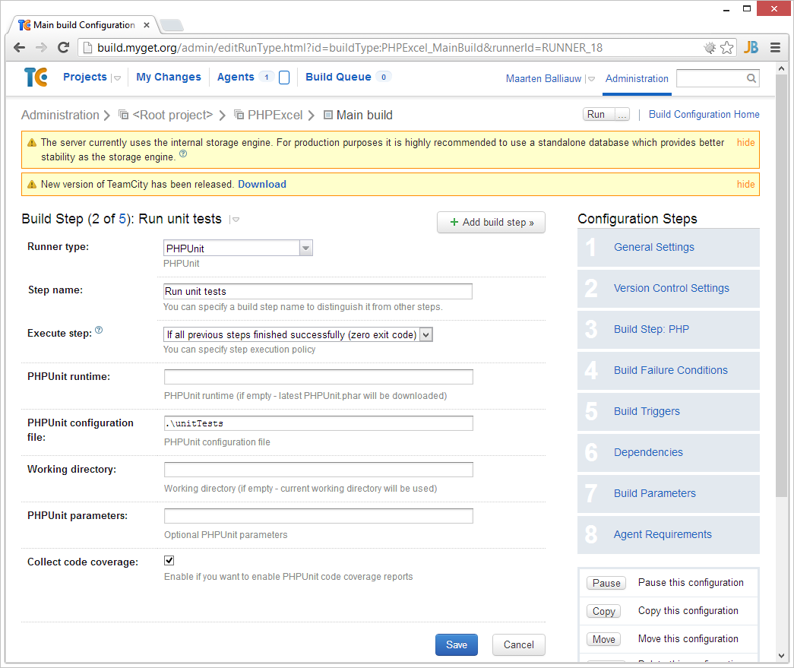

* **PHPUnit runtime**: The PHPUnit executable to use during build. If omitted, the latest PHPUnit version will be downloaded during build.
* **PHPUnit configuration file:** The path where the phpunit.xml file resides, or a full path to a specific PHPUnit configuration.
* **Working directory:** The working directory to use. If omitted, the current working directory will be used.
* **PHPUnit parameters**: Additional parameters for the PHPUnit command line.
* **Collect code coverage**: Enables code coverage analysis and reporting for the test run.

The *PHPUnit* runner will report unit test results to the TeamCity server:

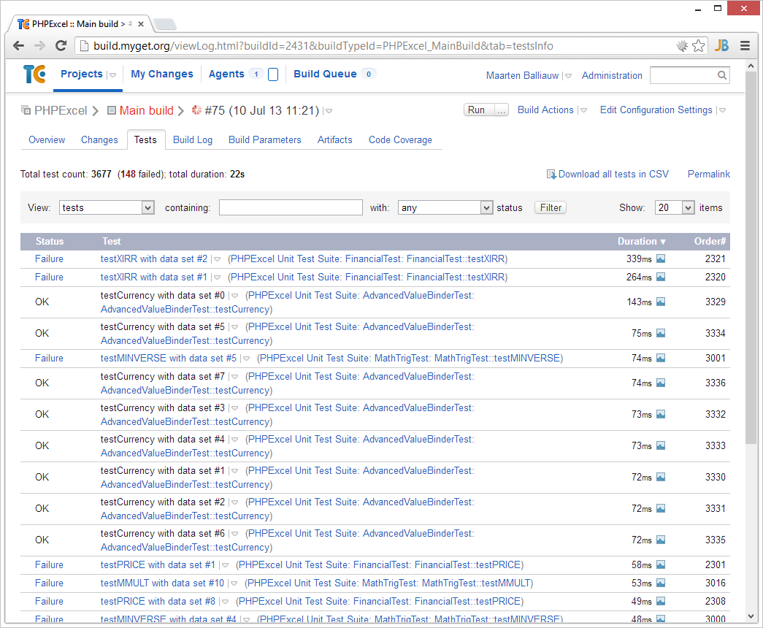

When the **Collect code coverage** option is enabled, the *PHPUnit* runner will publish a code coverage report to the TeamCity server:

